2 Byte – Frame Control
- 2 Byte – Duration/ID
- 4×6 Byte – Address 1 – 4
- 2 Byte – Sequence Control
- 2 Byte – QoS control
- 4 Byte – HT Control (only for 802.11n frames)
Therefore max size of MAC header would be 36 bytes (802.11n) & 32 bytes (802.11a/b/g). Below show a sample wireless frame & highlighted the major fields of MAC header. As you can see this frame uses only 3 Address fields (Not every frame uses all 4 address fields, this is used when DS to DS frame exchange like in wireless bridge ).
WLAN PHY standards

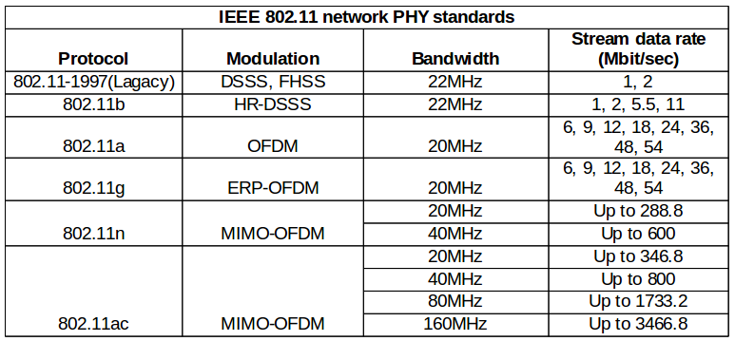

MIMO-OFDM
The 802.11n builds on previous 802.11 standards by adding multiple-input multiple-output (MIMO) and 40 MHz channels to the PHY (physical layer), and frame aggregation to the MAC layer.
MIMO is a technology that uses multiple antennas to coherently resolve more information than possible using a single antenna. One way it provides this is through Spatial Division Multiplexing (SDM), which spatially multiplexes multiple independent data streams, transferred simultaneously within one spectral channel of bandwidth. MIMO SDM can significantly increase data throughput as the number of resolved spatial data streams is increased. Each spatial stream requires a discrete antenna at both the transmitter and the receiver. In addition, MIMO technology requires a separate radio-frequency chain and analog-to-digital converter for each MIMO antenna, making it more expensive to implement than non-MIMO systems.
In the latest physical layers (802.11n and 802.11ac), data is transmitted using several possible channel bandwidths. The normal channel bandwidth in 802.11 WLANs is 20 MHz, whereas the 802.11n supports a 40 MHz bandwidth and the 802.11ac can utilize also 80 MHz and 160 MHz bandwidths. This allows transmission of much more data during the same time period.

What is Scanning and why is it required ?
Identification of network or discovering network is reffered as scanning. The reason for scanning is to determine a suitable access point (AP) to which client needs to connect/ roam in future.

Types of scanning
Scanning is mainly classified into two types, active and passive scanning.Generally client station performs both active and passive scanning. Passive scanning is default and it cannot be disabled but active scanning can be disabled in radio profile of client station.

WPA2 Process
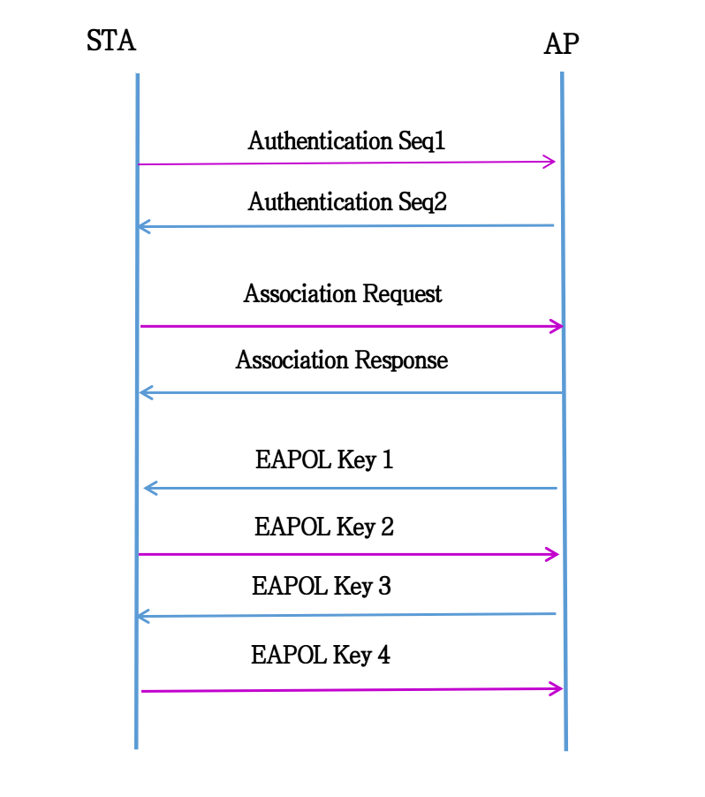

WPA3 Process

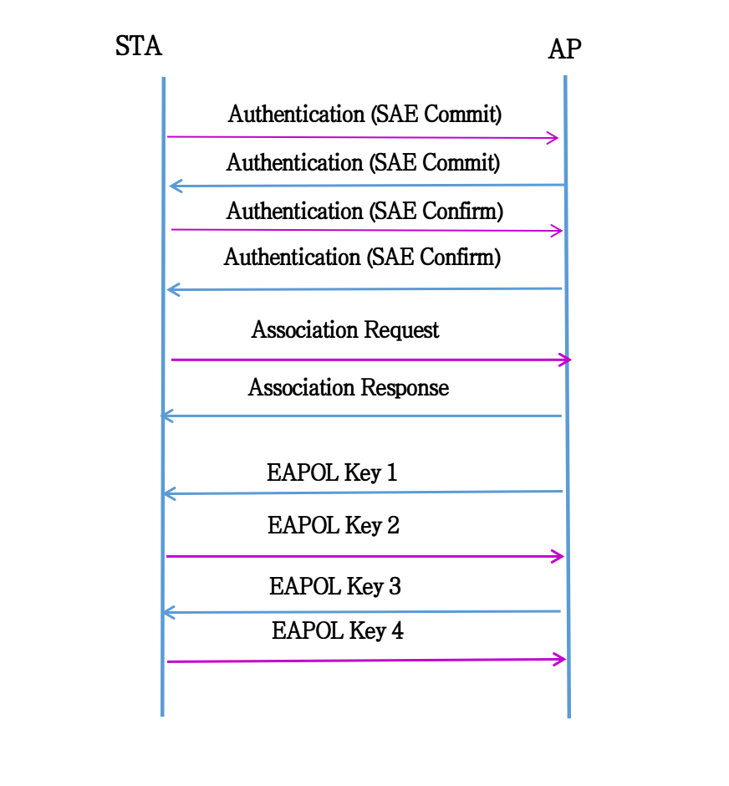
4-Way Handshake
The 4-Way Handshake is a final process used to generate pairwise transient keys for encryption of unicast transmissions and a group temporal key for encryption of broadcast/multicast transmissions.802.1X/EAP authentication is completed when the access point sends an EAP-Success frame and the AP can now initiate the 4-Way Handshake.
The 4-Way Handshake uses pseudorandom functions. A pseudorandom function(PRF) hashes various inputs to derive a pseudorandom value. The PMK is one of the inputs combined with other inputs to create the pairwise transient key. Some of the other inputsused by the pseudorandom function are called nonces. A nonce is a random numerical value that is generated one time only. A nonce is used in cryptographic operations and is associated with a given cryptographic key. In the case of the 4-Way Handshake, a nonce is associated with the PMK. A nonce is used only once and is never used again with the PMK. Two nonces are created by the 4-Way Handshake: the authenticator nonce (ANonce) and the supplicant nonce (SNonce).To create the pairwise transient key, the 4-Way Handshake uses a pseudorandom function that combines the pairwise master key, a numerical authenticator nonce, a supplicant nonce, the authenticator’s MAC address (AA), and the supplicant’s MAC address (SPA).
The following is a simplified depiction of the formula used by the pseudorandom func- tion (PRF) to derive a pairwise transient key:
- PTK = PRF (PMK + ANonce + SNonce + AA + SPA)
The 4-Way Handshake consists of the following steps:
- 4-Way Handshake Message 1 The authenticator and supplicant each randomly create their respective nonces. The authenticator sends an EAPOL-Key frame containing an ANonce to the supplicant. The supplicant now has all the necessary inputs for the pseudorandom function. The supplicant derives a PTK from the PMK, ANonce, SNonce, and MAC addresses. The supplicant is now in possession of a pairwise transient key that can be used to encrypt unicast traffic.
- 4-Way Handshake Message 2 The supplicant sends an EAPOL-Key frame containing an SNonce to the authenticator. The authenticator now has all the necessary inputs for the pseudorandom function. The supplicant also sends its RSN information element capabilities to the authenticator and a message integrity code (MIC). The authenticator derives a PTK from the PMK, ANonce, SNonce, and MAC addresses. The authenticator also validates the MIC. The authenticator is now in possession of a pairwise transient key that can be used to encrypt unicast traffic.
- 4-Way Handshake Message 3 If necessary, the authenticator derives a GTK from the GMK. The authenticator sends an EAPOL-Key frame to the supplicant containing the ANonce, the authenticator’s RSN information element capabilities, and an MIC. The EAPOL-Key frame may also contain a message to the supplicant to install the temporal keys. Finally, the GTK will be delivered inside this unicast EAPOL-Key frame to the supplicant. The confidentiality of the GTK is protected because it will be encrypted with the PTK.
- 4-Way Handshake Message 4 The supplicant sends the final EAPOL-Key frame to the authenticator to confirm that the temporal keys have been installed.
- Controlled Port Unlocked

1) Authentication
2) WLAN Encription Methods
3) WPA/WPA2
4) Robust Security Networks
5) Four-Way Handshake

Authentication

1) Authentication is the first of two steps required to connect to the 802.11 basic service set.
2) The 802.11 authentication merely establishes an initial connection between the client and the access point
3) The 802.11-2007 standard specifies two different methods of authentication:
a) Open system Authentication.
b) Shared key authentication,

Open system Authentication

Open system and 802.11X/EAP Authentication

Shared Key Authentication

WLAN encryption methods

1) The 802.11-2007 standard defines three encryption methods that operate at layer 2 of the OSI model:
a) Wired Equivalent privacy(WEP).
b) Temporary Key Integration Protocol(TKIP).
c) CTR with CBC-MAC Protocol(CCMP).
2) WEP, TKIP, CCMP are used to encrypt the MSDU payload of an 802.11 data frame.

Wired Equivalent Privacy

1) Wired Equivalent Privacy is a layer 2 security protocol that uses the RC4 streaming cipher.
2) 64-bit WEP uses a secret 40-bit static key, which is combined with a 24-bit number selected by the card’s device drivers.
3) This 24-bit number, known as the initialization vector(IV)
4) Pseudo random RC4 algorithm is used to generate keystream.
5) Keystream then combined with the plain-text data bits by using a Boolean XOR process.

WEP encryption process

WEP MPDU Format

Temporary Key Integration Protocol

1) TKIP is an enhancement of WEP.
2) TKIP uses the ARC4 algorithm for performing its encryption and decryption processes.
3) TKIP uses dynamically created encryption keys as opposed to the static keys.
4) Any two radios use a 4-Way Handshake process to create dynamic unicast keys that are unique to those two radios.
5) TKIP starts with a 128-bit temporal key.
6) The 128-bit temporal key is a dynamically generated key that comes from a 4-Way Handshake creation process.
7) This key is identical on the AP and client pair.
8) The 128-bit temporal key can either be a pairwise transient key (PTK) used to encrypt unicast traffic.
9) or a group temporal key (GTK) used to encrypt broadcast and multicast traffic

Temporary Key Integration Protocol

TKIP encryption and data integrity process

TKIP MPDU

CTR with CBC-MAC Protocol(CCMP)

1) The full phrase of counter mode with the Cipher-Block Chaining Message Authentication protocol is represented by the acronym of CCMP.
2) certain fields in the MPDU header are used to construct the additional authentication data (AAD).
3) This information is used for data integrity of portions of the MAC header.
4) CTR is used to provide data confidentiality.
5) The CBC-MAC is used for authentication and integrity.

CTR with CBC-MAC Protocol(CCMP)

CCMP encryption and data integrity process

Additional authentication data

CCMP MPDU

Wifi Protected Access(WPA)

1)Temporal Key Integrity Protocol (TKIP) was adopted for WPA.
2) WPA also includes a Message Integrity Check.
3) WPA2 is the upgraded version of WPA which uses CCMP/AES encryption.
4) The various protection mechanisms of WPA are.
a) WPA-Personal(WPA-PSK(Pre shared key))
b) WPA-Enterprise(WPA-802.11X mode).
c) Wifi Protected setup

Robust security networks

1) The 802.11-2007 standard defines what is known as a robust security network (RSN) and robust security network associations (RSNAs).
2) A robust security network association (RSNA) requires two 802.11 stations (STAs) to establish procedures to
a) Authenticate
b) Associate
c) create dynamic encryption keys through a process known as the 4-Way Handshake
3) CCMP/AES encryption is the mandated encryption method, while TKIP/RC4 is an optional encryption method.

4-WAY HANDSHAKE

1) The 4-Way Handshake is a final process used to generate pairwise transient keys for encryption of unicast transmissions
2) and a group temporal key for encryption of broadcast/multicast transmissions.
3) The 4-Way Handshake uses four EAPOL-Key frame messages between the authenticator and the supplicant
4) 802.1X/EAP authentication is completed when the access point sends an EAP-Success frame and the AP can now initiate the 4-Way Handshake

The 4 way handshake

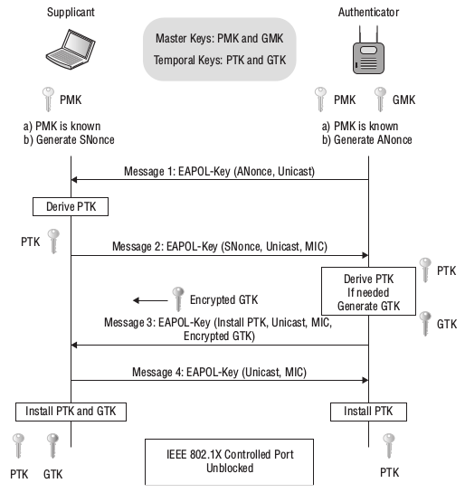
PMK is Pairwise Transmit Key it is generated by the both AP and STA with the help of SSID and PASSWORD.
In the message 1 the AP will send the Anonce to the STA
In the message 2 the STA will construct the PTK = sudo random function – 384bits(PMK + SNONCE + ANONCE + AP MAC + STA MAC ) in CCMP and 512 bits in TKIP. And the station will generate the MIC using the PTK as 128 (kck) + 128 (kek) + 128 bits (tk) the station will construct the MIC using the (kek) + data.
In the AP will check the MIC caluculation in the message 2.And it will send the message 3.AP will get the message 4 as ACK.

Anonce is generated by the AP with the help of the AP Time and the mac address.
Snonce is generated by the STA with the help of the STA Time and the mac address.
1) Frist the AP Sents the eapol packet 1 to the STA with PMK and the Anonce.
2) STA derives the Snonce and the PTK (256 bits)
i) The frist 64 bit ECK,
ii) Second 64 bits is E

3) The station will send the only the last 64 bits with the Snonce.
4) The AP matches the MIC with is MIC and then it sends the 3rd eapol packet with generated PTK and it needed it will generate the GTK (Group Transist Key)

Carrier Sense/Clear Channel Assessment (CS/CCA)
Transmit (Tx)
When a station needs to transmit a frame, it must first check to see whether the wireless medium is available. This is done by the CS/CCA process. After the medium is available and it is the station’s turn to transmit, the station will transmit the frame and immediately switch back to receive mode.

Receive (Rx)

If the CS/CCA identifies that the medium is busy, the station needs to be able to identify
whether the medium is busy because of another device transmitting a frame. The transmitting
station will precede that data portion of the frame with a preamble. This preamble contains
a string of 0s and 1s that the receiving station can identify and synchronize with, essentially
alerting the receiving station to the transmission. The preamble also includes a Start Frame
Delimiter field, which the receiving station uses to identify the beginning of the frame. After
the preamble, the length field in the frame header tells the receiving station how long the frame
is. After the entire frame is received, if the frame is determined to be intact by the station it is
addressed to, that station will reply to the transmitting station with an acknowledgment
frame (ACK).

PLCP Service Data Unit
The PSDU is the data that the PHY transmits. The PSDU is equivalent to the MPDU that
is passed down from the Data-Link layer.

PLCP Protocol Data Unit
When the PLCP receives the PSDU, it then prepares the PSDU to be transmitted and creates
the PLCP Protocol Data Unit (PPDU). The PLCP adds a preamble and PHY header to the
PSDU. The preamble is used for synchronization between transmitting and receiving 802.11
radios. When the PPDU is created, the PMD sublayer takes the PPDU and modulates the data
bits and begins transmitting.

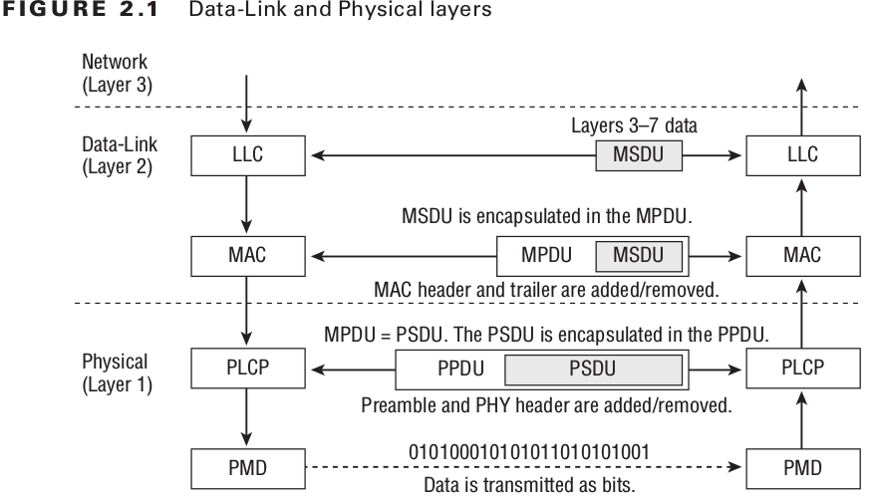

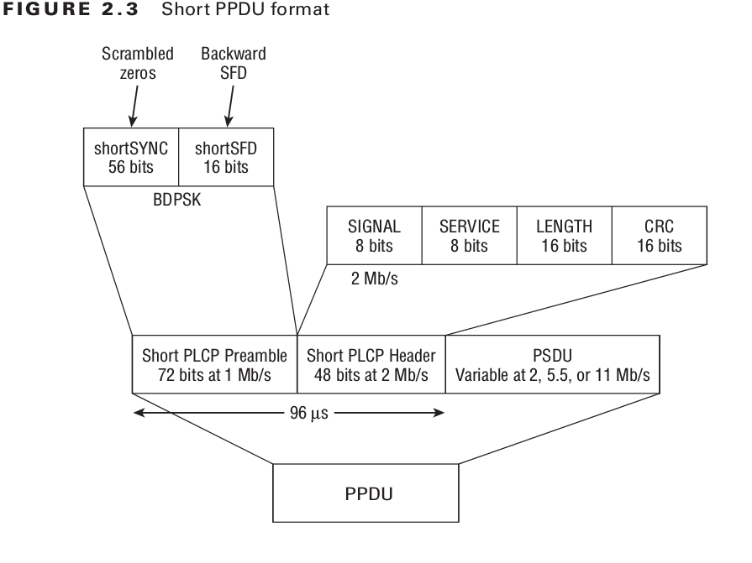
Physical Medium Dependent
When transmitting, the PMD receives the PPDU from the PLCP sublayer. The PMD is then
responsible for transmitting the Physical layer data unit. The PMD transmits the data as RF
modulated 1s and 0s. When receiving, the PMD listens to the RF, interpreting the modu-
lated RF signal as 1s and 0s and then passing the received data up to the PLCP sublayer.

PLCP Protocol Data Unit
The PLCP Protocol Data Unit consists of three parts: PLCP Preamble, PLCP Header, and
PSDU. When the PLCP layer receives the PSDU from the MAC layer, the appropriate PLCP
Preamble and PLCP Header are added to the PSDU to create the PPDU.

PLCP Preamble
When transmitting data, the transmitting station alerts the receiving station of the trans-
mission by sending a PLCP Preamble at the beginning of the transmission. The preamble
is a string of 0 and 1 bits that are used to synchronize incoming transmissions. The IEEE
802.11-2007 standard defi nes three different preambles in the Long PPDU format, the Short
PPDU format, and the OFDM PLCP preamble. The 802.11n amendment further defi nes
three additional preambles in three different PPDUs: non-HT legacy PPDU, HT-mixed
PPDU, and HT-Greenfi eld PPDU. The Long PLCP preamble, the Short PLCP preamble, and
the OFDM PLCP preambles are described in the following sections, while the other three
are discussed later in this chapter along with the rest of their PPDUs.

OFDM PLCP Preamble

The OFDM PLCP Preamble, also referred to as the OFDM training structure, consists of
10 short symbols and 2 long symbols, as shown in Figure 2.4. In the figure, t1 to t10 iden-
tify the short training symbols, GI2 is a long guard interval, and T1 and T2 identify the
long training symbols. Following the PLCP preamble is the SIGNAL field and the DATA
fields, each with a guard interval preceding them. The total training length is 16 μs. A short
OFDM training symbol consists of 12 subcarriers while a long OFDM training symbol
consists of 53 subcarriers.

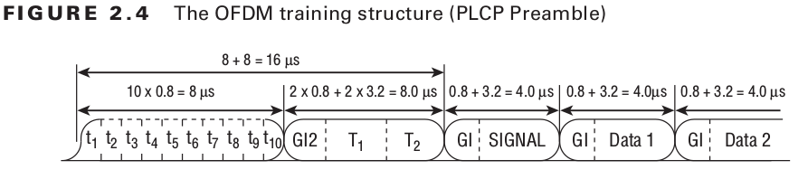

1) Institute of Electrical and Electronic Engineering (IEEE) (Release in 1997)
i) Worked on 2.4GHz (Unlicensed Band)
2) IEEE 802.11b (Released in 1999)
i) Operating Frequency = 2.4 Ghz
ii) Max Datarate = 11 Mbps
iii) using in the Microwave,Bluetooth
3) IEEE 802.11a (Released in 2002)
i) Operating Frequency = 5 Ghz
ii) Datarate = 15 to 54 Mbps
ii) Multiplexing Technique =OFDM
iii) Effective range is small due to higher frequency
4) IEEE 802.11g (Released in 2003)
i) Operating Frequency = 2.4GHz
ii) Transmission Technique = OFDM
iii) Backward Compatible
5) IEEE 802.11n (Release in 2004)

CWAP – MAC Header : QoS Control
When the service period is over, the AP informs the STA about the Service Period (EOSP) using the Power Management bits within the Frame Control field of transmitted frames. If the EOSP bit is not set, the station remains awake and waits for the other incoming frames. Once the EOSP bit is set, the station go back into sleep.
Concerning the Quality of Service support, the usage of the novel Enhanced Distributed Channel Access (EDCA) MAC layer (mandatory to use the U-APSD protocol), also introduces important changes in order to support the applications QoS demands. The EDCA defines four access categories which can be used to classify the traffic, as described in Table I.
QoS Control is a 16-bit field that identifies the Quality of Service (QoS) parameter of a data frame (only in data frame type QoS-Data).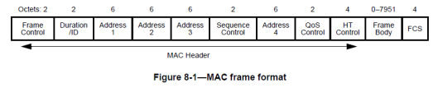

QoS Control field is comprised of five subfields
1. [bit 0-3 ] Traffic Identifier (TID)
2. [bit 4 ] End of Service Period (EOSP)
3. [bit 5-6 ] ACK Policy
4. [bit 7 ] Reserved
5. [bit 8-15 ] TXOP limit, TXOP duration, AP PS buffer state, Queue Size

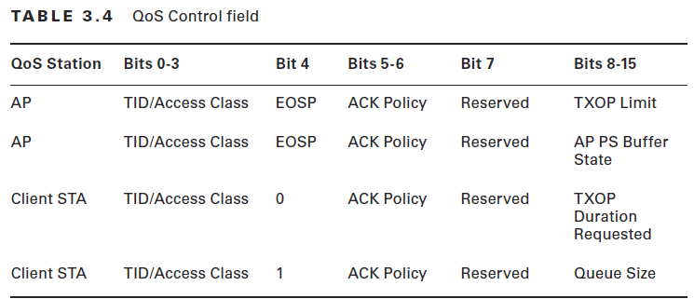
Here is the brief description of the QoS subfields
1st subfield (TID – Traffic Indicator)
4 bit value used to identify the user priority (UP) and traffic Access Category(AC) of a QoS data frame. 802.11 WMM clients use WMM-PS (power save) to indicate to an AP that STA is awake. Unlike in legacy PS, WMM-PS client can ask to deliver more than 1 frame.
2nd subfield (EOSP- End of Service Period)
1 bit value to indicate the end of a service period. If this bit set to 1, then client can go back to asleep.
3rd subfield (Acknowledge)
Specify the 2-bit Acknowledgement policy. There are four different options available
ACK :
No-ACK :
No Explicit ACK :
Block ACK:
4th subfield (Reserved)
Allocated for future use
5th subfiled
TXOP Limit: Indicate the transmitt opportunity granted by the AP
AP PS Buffer State : AP use this to indicate PS buffer state for a given client station.
TXOP Duration Requested: Client use this to tell AP how much time client station wants for its next TXOP. AP may choose to assign shorter TXOP as well.
Queue Size: Client station use that to inform AP how much buffered traffic it has to send. AP can use this information to determine duration for next TXOP to that client
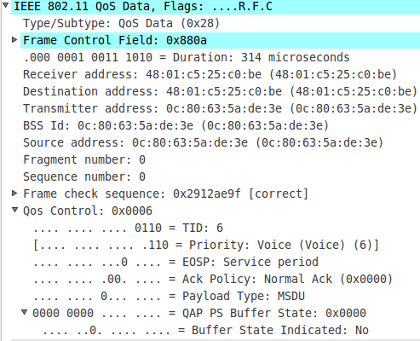

ERP Field
It is used to when AP and two STA’s are in g mode with supports data rates 54 Mbps and 2.4 Ghz.
The third station is connect in middle which as the data rate 11 Mbps and supports 2.4 Ghz.
Then we need to use the ERP fields protection mode and non_protection mode to reduce the data rate from 54 Mbps to 11 Mbps
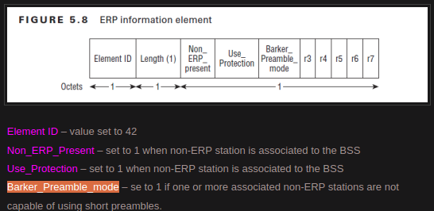

https://mrncciew.com/2014/11/02/cwap-802-11-protection-mechanism/

Management frames allow wireless devices to form a network and manage the connections.
12 management frames
Beacon frame- 1000
Probe request frame- 0100
Probe response frame-0101
Authentication frame- 1011
Association request frame- 0000
Association response frame- 0001
Reassociation request- 0010
Reassociation response- 001
Disassociation-1010
Deauthentication-1100
ATIM- 1001
Action- 1101

Management Frame Format

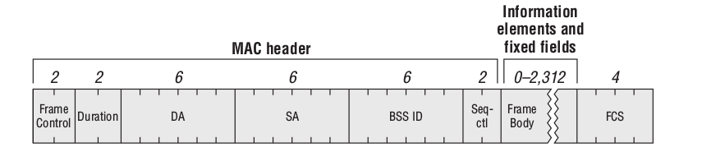

Beacon Frame
Beacon frames are used by access points to communicate throughout the serviced area the characteristics of the connection offered to the cell members.
Beacon frames are sent periodically, at a time called target beacon transmission time(TBTT). The beacon time interval is 100TU
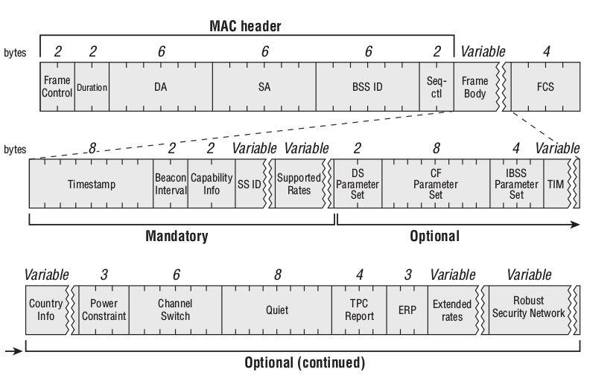

Capability information field
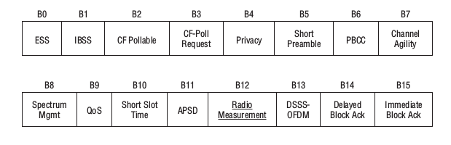

Beacon fra

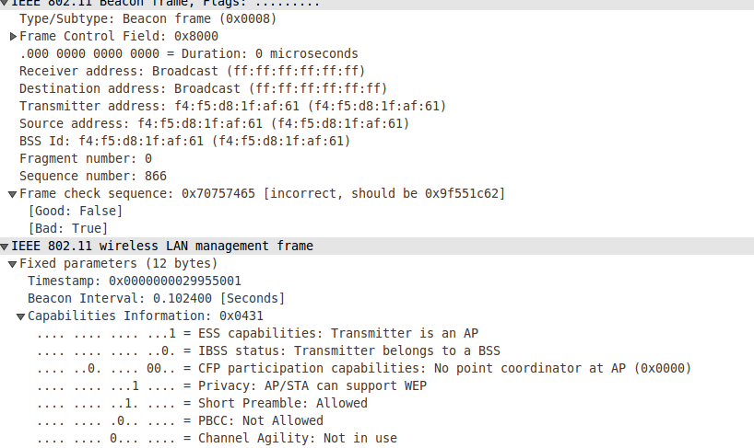

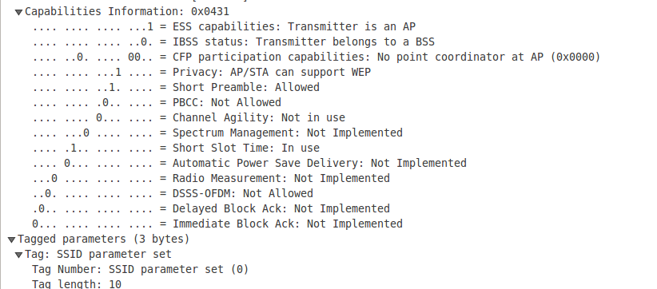

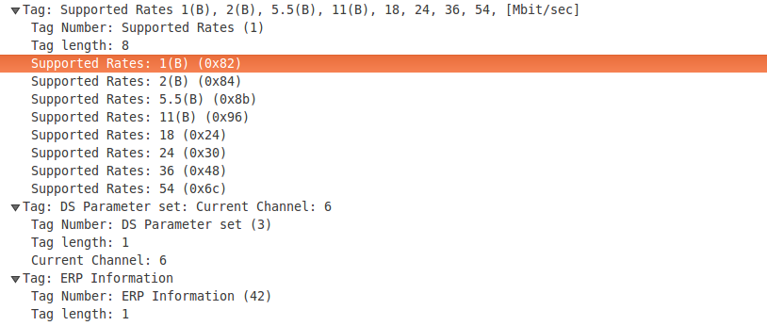

Beacons are sent periodically at a time called Target Beacon Transmission Time (TBTT)
1 TU = 1024 microseconds
Beacon interval =100 TU (100x 1024 microseconds or 102.4 milliseconds)
Below shows a beacon frame capture. In the frame body section there are few mandatory fields & few optional fields. Here are the mandatory fields in a Beacon frame.
1. Timestamp (8 byte)
2. Beacon Interval (2 byte)
3. Capability info (2 byte)
4. SSID (variable size)
5. Supported Rates (variable size)

Probe Request frame

1) Probe request is management frame which aimed at asking what network is available on this channel.
2) The probe requests are usually sent to the broadcast DA address(ff:ff:ff:ff:ff:ff).
3) Once the probe is sent, the emitting starts a ProbeTimer countdown and waits for answers.
4) This Probe time is decided by vendor, but it is usually a lot shorter than a beacon interval.
5) At the end of the timer, the station processes the answers it has received.
6) If no answer was received,the station moves to the next channel and repeats the discovery process.
7) The purpose of a probe request is typically to discover APS and their supported networks.

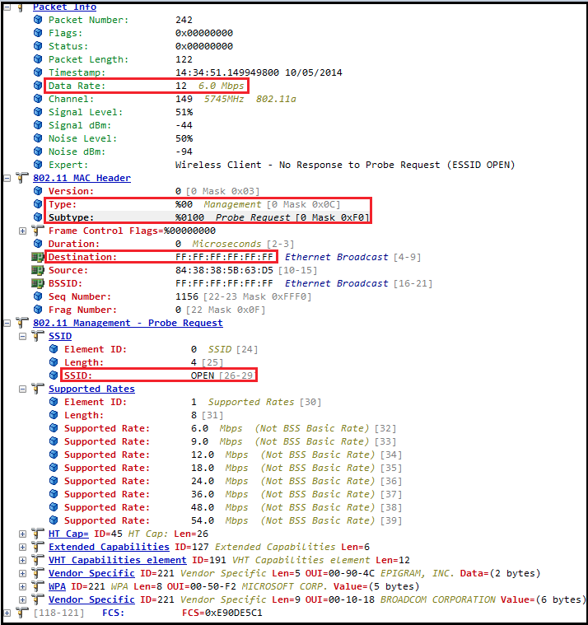

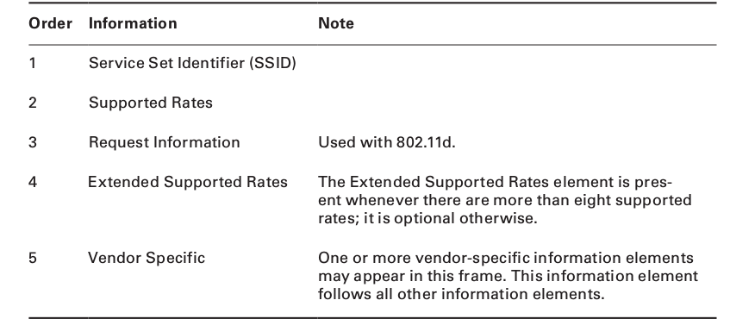

Probe response

1) Upon receiving a probe request frame, a station in an IBSS or an AP will respond with a probe response frame.
2) The probe response is sent as a unicast frame.
3) The probe response is sent at the lowest common rate supported by both the station sending the probe request and the answering AP.
4) The probe response should be acknowledged by the receiving station,just like any other unicast frame.
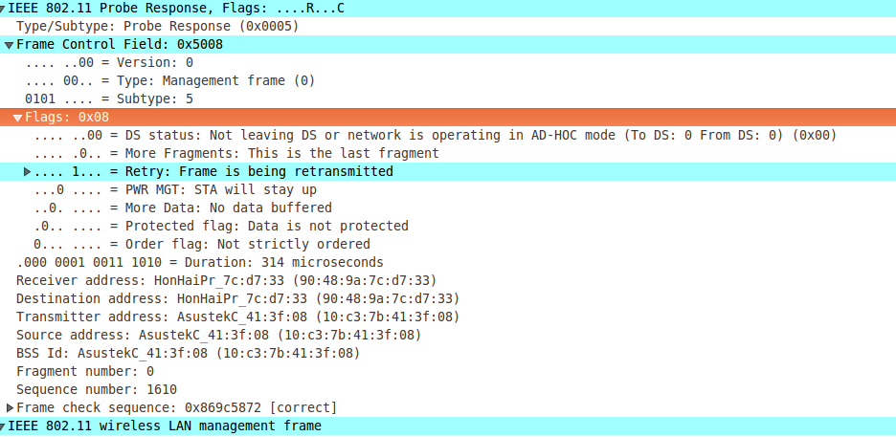

Authentication frame

Two types of authentication
1) Open system
2) Shared key exchange

1) The station sends the authentication frame to the AP to validate the device type means verify that the requesting station has proper 802.11 capabilities or not.
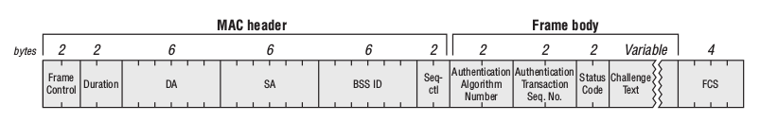

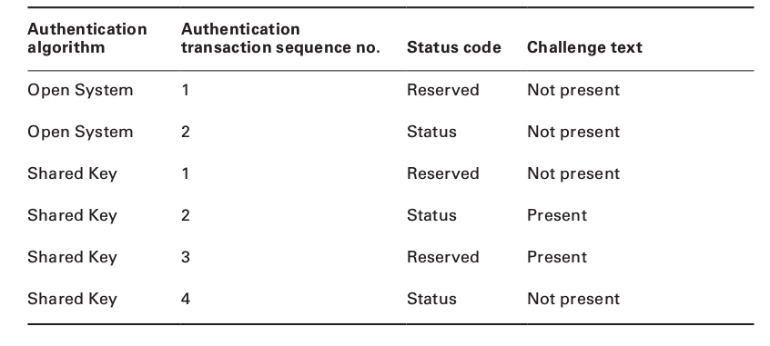

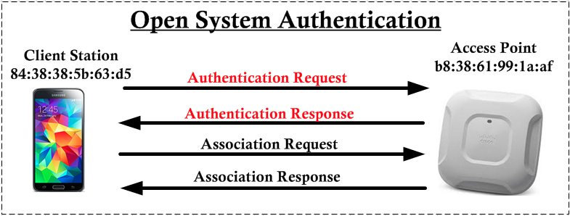

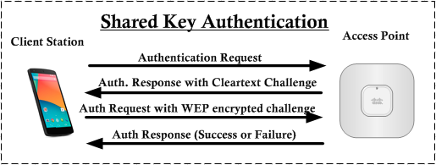

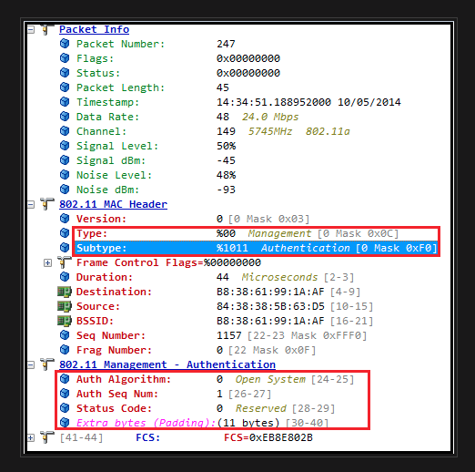

Association request frame
1) The Association frame is sent by the station to the Ap.
2) The purpose of this exchange is for the station to join the cell and obtaina cell member identifier called an association ID.
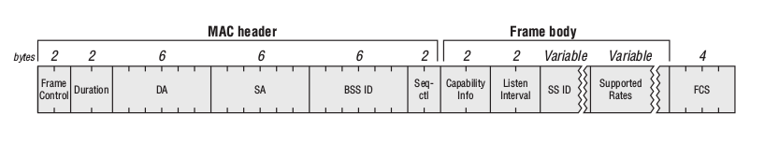

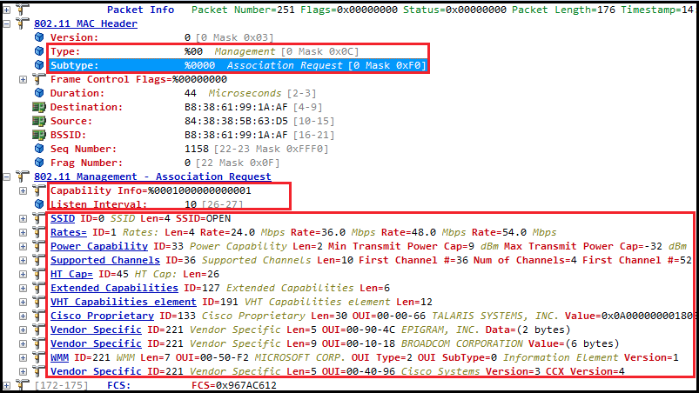

Association Response frame

1) After acknowledging the request frame, the AP examines each field of the request and verifies whether they all matches its own 802.11 parameters.
2) Once the station receives its association ID, it is associated to the cell and can start to communicate, sending data or moving to a second layer of authentication.
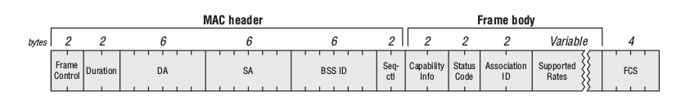
3) If the association fails, the station receives in the status code the reason for the failure.

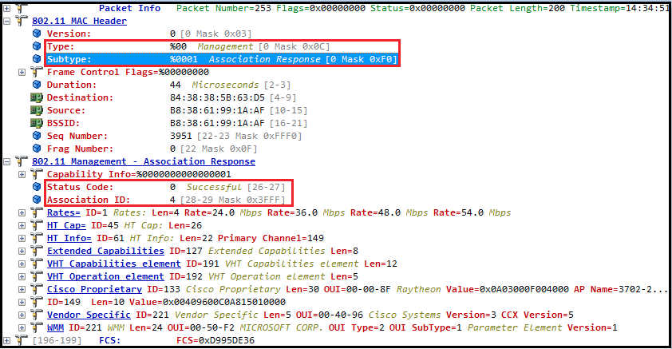

Deauthentication frame
1) The station or AP can also send a deaunthentication frame.
2)This frame is used when all communications are terminated.

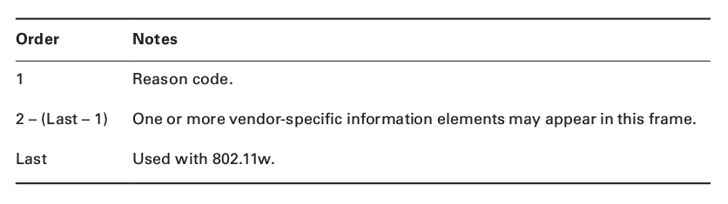

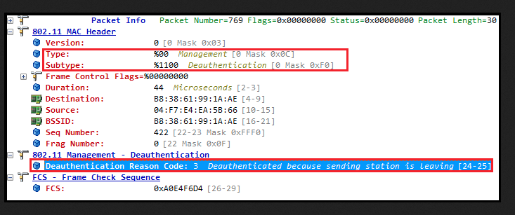

Disassociation Frame
1) Once a station is associated to an AP, either side can terminate the association at any time by sending a diassociation frame.
2) The disassociation frame may be the unicast or a broadcast

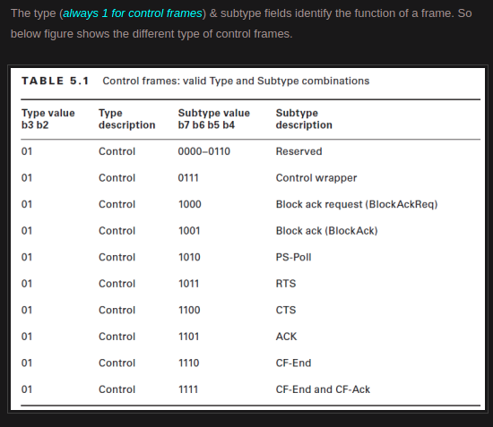

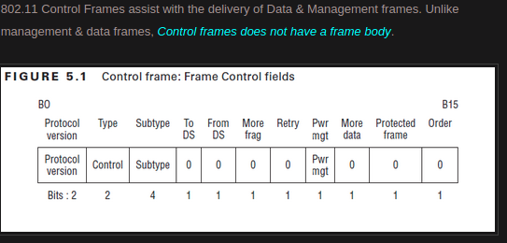

2. Block Ack Request (BAR)
When a station intend to use Block ACK mechanism to transmit QoS data, it first check to see whether the peer station is capable of Block ACK. Then send block of QoS data frames & requesting all QoS data frame to ACK by sending Block ACK Request (BAR) to receiving station. Here is the wireshark filter you can use.
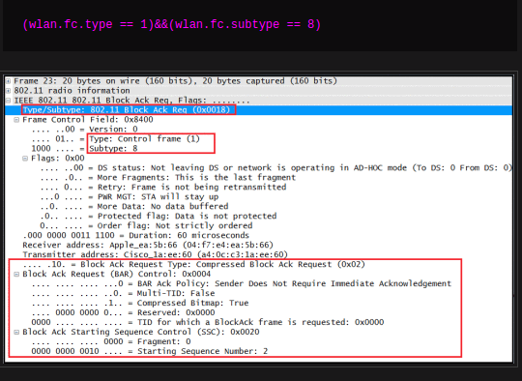

http://www.hitchhikersguidetolearning.com/2017/09/17/block-ack-frame-formats-block-ack-request/
https://mrncciew.com/2014/11/01/cwap-802-11-block-ack/

RTS and CTS
1) CSMA/CA
2) Distributed Coordination Function
3) EDCA
4) Interface Spaces
5) Random Backoff/Contention Window
6) TXOP
7) Frame Transmission

CSMA/CA

Idea: The chance of collision can be reduced if a station senses the medium before trying to use it.
Physical Carrier Sense (Clear Channel Assessment)
ED (Energy Detection)
CS (Carrier Sense)
Virtual Carrier Sense (Network Allocation Vector)
Duration value set in each frame’s MAC header where other stations set their NAV to this if the sense medium is busy.

CSMA/CA Flow Chart

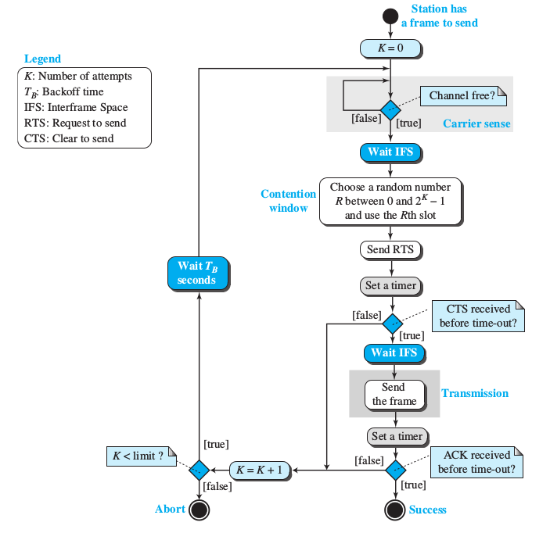

Distributed Coordination Function
The four main Component of DCF
1) Carrier Sense
2) Duration/ID field
3) Interframe Space
4) Random backoff timer

Enhanced Distributed Channel Access
1) AIFS
2) QoS-Based Random Backoff Timer
3) TxOP

Interframe Space

* The IFS is a quiet period that APs and stations must wait before any 802.11 frame transmission.

* The purpose of an IFS is both to provide a buffer between frames to avoid interference as well as to add control and to prioritize frame transmissions.

* The length of the IFS time is depends on previous frame type, following frame type, access category, coordination function in use & PHY type as well.

Short Interframe Space (SIFS)
1) It is the shortest IFS, has highest level of priority.

Reduced Interframe Space (RIFS)
2) RIFS were introduced with 802.11n to improve efficiency for transmissions to the same receiver in which a SIFS-separated response is not required, such as a transmission burst (CFB-Contention Free Burst).

DCF Interframe Space (DIFS)
DIFS = SIFS + 2 x SlotTime
Extended Interframe Space (EIFS)
1) EIFS (in DCF) = SIFS + DIFS + ACK_Tx_Time
2) EIFS 802.11b/g/n devices using DSSS = 364μS
3) EIFS 802.11g/n devices using OFDM = 160μS
4) EIFS 802.11a/n devices (5GHz) = 160μS
5) EIFS (in EDCA) = SIFS +R AIFS[AC] + ACK_Tx_Time
Arbitration Interframe Space (AIFS)
1) Shall be used by the QoS STA's.
2) AIFS[AC] = AIFSN[AC] × SlotTime + SIFSTime
PCF Interframe Space (PIFS)
1) Used by STAs during the contention-free period (CFP) in PCF mode.

Random backoff

1) An 802.11 station may contend for the medium during a window of time known as the backoff time.
2) STA shall use the Random back-off after the defer period to avoid collisions.
3) Backoff Time = Random() × aSlotTime
4) Random() = Pseudo-random integer select from interval 0,CW(Contention Window) .
5) aSlotTime =Slot time sizes are dependent on the physical layer specifi cation (PHY) in use (DSSS, OFDM,etc. ).

Contention Window

1) CW = 2^k – 1, aCWmin ≤ CW ≤ aCWmax.
2) Contention window (CW) parameter shall take an initial value of aCWmin.
3) The CW shall take the next value in the series every time an unsuccessful attempt to transmit an MPDU .
4) Once it reaches aCWmax, the CW shall remain at the value of aCWmax until the CW is reset.
5) In EDCA medium access (QoS stations & AP), each AC has a CW_min & CW_max.
6) To contend for medium access after the IFS, each station selects a backoff value called random backoff period and is selected at random by the STA from a window of possible values called a contention window (CW)

TXOP : Transmit Opportunity

1) EDCA introduce this TXOP which is a time period where one device, called TXOP holder has unfettered acccess to the channel for data transmission.
2) 802.11e standard defines default TXOP limit value for each AC, but values can be configured on AP

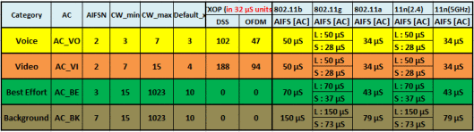

Arbitration Flowchart

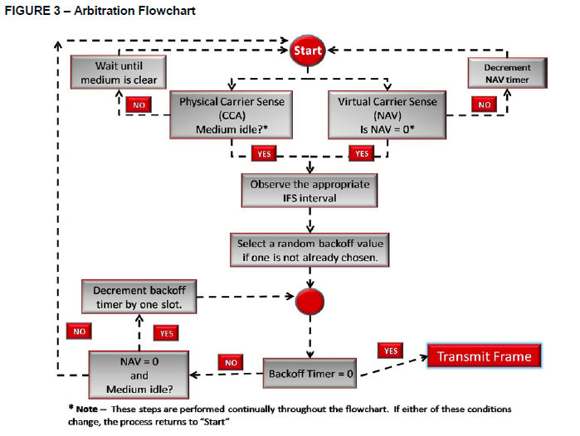

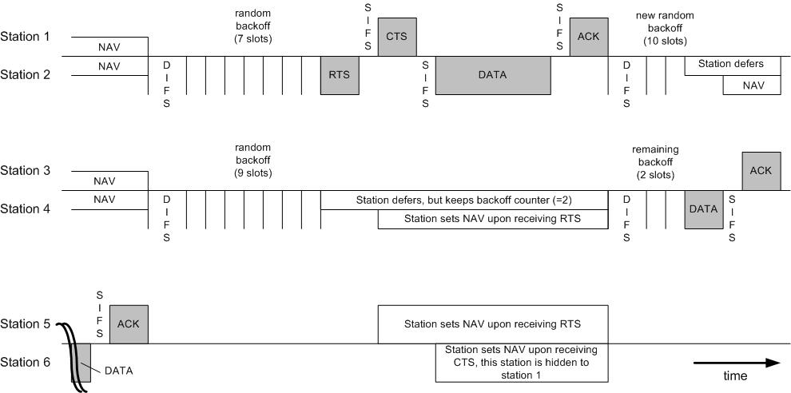
Frame Transmission

Block Ack mechanism & Qos Control Field
1) Initially defined in 802.11e standard as an optional scheme to improve the MAC efficiency.
2) In 802.11n enhances the Block Ack mechanism made it mandatory to support all 802.11n capable devices(HT devices)
3) Instead of transmitting individual ACK for every data frame, multiple data frames can be acknowledged together using BA frame.
4) The BA mechanism improves the channel efficiency by aggregating several ACKs into one frame.

BLOCK ACK TYPES

1) Immediate Block Ack
2) Delay Block Ack

Different Phases of Block Ack

Immediate Block Ack

Delayed Block Ack

Block Ack Parameter Set

Addba Request

Addba Response

BlockAck Request Frame

BlockAck Frame Format

Aggregation

A-MSDU Aggregation

Power Management
The EOSP Field is used to in the Power Management if the last sequence packet is fragmented then the EOSP is set to 1 representing the last sequence packet is and more fragment bit is set to 1 representing the packet related to that sequence number is fragmented.it is used in the a and g.

1) Introduction
2) Basic Power Management Steps
3) Associate Identifier (AID)
4) Doze State
5) TIM
6) DTIM

Introduction
1) A wireless radio can perform one of the 4 activities. Power consumed by each activity increases in the given order
1) Asleep
2) Idle & awake
3) Receiving
4) Transmitting
2) There are 3 methods of power management used in 802.11
1) 802.11 power management
2) U-APSD (Unscheduled Automatic Power Save Delivery) from 802.11e
amendment
3) PSMP (Power Save Multi-Poll) from 802.11n amendment
Basic Power Management Steps
The basic power management structure summarized in 4 steps
1) Before a STA goes into the doze state, it sends a frame,usually null data frame, to the AP indicating that powe management (PM) is enabled.
2) Once STA indicated,that it is in Power Save mode, the AP begins to buffer all frame destined to that station
3) When the station goes into awake state, it sends a frame to the AP in order to begin the data retrievel process.
4) When AP has finished sending all buffered data to the station, the station goes back into the doze state.
1) 802.11 power management
802.11 Legacy-PSM
This subsection describe the IEEE 802.11 Legacy Power Save Mode (Legacy-PSM) algorithm.
When Communicating using the IEEE 802.11 standard,an Access Point (AP) periodically broadcasts Beacon Frames.
Apart from other control related infromation,the Beacon Frames also contain specific information related with the power saving operation.In Legacy-PSM a Station (STA) can be in two main different states:
Continuous Aware Mode (CAM) or Power Saving Mode (PSM),which is also known as sleep mode.

When a Station (STA) is in sleep Mode,the AP handles the frames addressed to it by buffering them locally.All the STAs operating the Legacy-PSM must wake up regularly to receive the Beacon Frames.Therefore,the STA can recognize wheather the AP has buffered frames addressed to it by analyzing the Traffic Indicator Map (TIM) field of the Beacon Frame.

Once a STA wakes up to receive the Beacon Frame, it might goes back into sleep mode if there are no queued frames in the AP to be received. The AP should always be informed about power saving mode changes.
If the STA recognizes that there are frames buffered for it in the AP, it sends back a request to receive those frames by transmitting a PS-Poll frame to the AP. When the AP receives such frame, it must reply with an Acknowledgment (ACK) or directly with a queued data frame. If the AP has more than one frame to send for a certain STA, it sets the MoreData flag, forcing the STA to be awake to receive all the pending frames. If the frames stay buffered for too long, the AP might use an aging function to delete these frames. Due to this dependency with the Beacon Frame, a STA operating in Legacy-PSM is characterized as reactive.

Every 802.11 power management method begin when the STA associates to the BSS. When AP send “Association Response” frame to the STA, an Association Identifier (AID) value present in the AID fixed parameter field (16 bit) as shown below. AID is presence in Association Response or Reassoication Response frames.
STA is allowed to go to “doze” state after the AP has been notified that station is about to enter power save mode. STA will use null data frame with Power Management bit set to 1 as shown below.
Stations will wake up from doze state for one of the 3 reason
1. if station has a frame to send
2. based on STA internal timing mechanism.
Traffic Indication Map (TIM)
TIM is an information element & it has below structure.
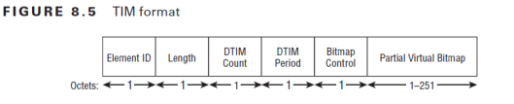
Element ID (1 byte) : Value 5 indicate it is a TIM
Length (1 byte) : Length of the info carrying fields (DTIM count, DTIM Period, Bitmap Control, Partial Virtual Bitmap)
DTIM Count (1 byte) : Incremental beacon frames until the next DTIM.
DTIM Period (1 byte) : number of beacon frames between DTIM beacon.
Bitmap Control (1 byte) : to indicate multicast/broadcast are buffered at the AP & use as space save (bitmap offset)
Partial Virtual Bitmap(1-251 byte) : Series of flags indicating whether each associated STA has unicast frames buffered at the AP. Each bit in this filed corresponds to a AID of a STA.
Here is a TIM information element in a beacon frame. Note that DTIM period is 3 in the below, which mean every 3 beacon one DTIM will be advertised. DTIM count is 2 indicating in 2 beacon time there will be a DTIM
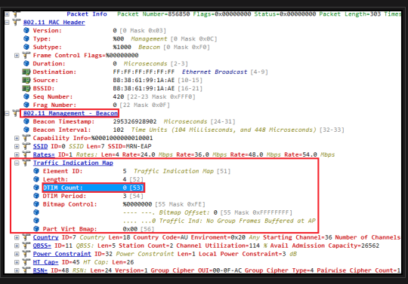

IEEE 802.11 U-APSD
This subsection describes the U-APSD power saving mode. Unlike Legacy-PSM, the U-APSD does not relay on Beacon Frames to control the stations power management. When operating in U-APSD, a STA does not need to wake up periodically to receive the Beacon Frames. Instead, the STA has a proactive behavior, meaning that it can wake up whenever desired.
To inform the AP about its power state, the STA sends a trigger frame (QoS data or QoS Null messages) to it. These trigger frames can be sent to the AP anytime and do not need to be sent after receiving a Beacon Frame.
Upon receiving a trigger frame, if there are pending data to the STA, the AP allocates a Service Period (SP) to the STA. The transmission starts and the AP can send all the pending frames, limited by the maximum service period time length, following the Transmission Opportunity rules (TXOP).
When the service period is over, the AP informs the STA about the Service Period (EOSP) using the Power Management bits within the Frame Control field of transmitted frames. If the EOSP bit is not set, the station remains awake and waits for the other incoming frames. Once the EOSP bit is set, the station go back into sleep.
Concerning the Quality of Service support, the usage of the novel Enhanced Distributed Channel Access (EDCA) MAC layer (mandatory to use the U-APSD protocol), also introduces important changes in order to support the applications QoS demands. The EDCA defines four access categories which can be used to classify the traffic, as described in Table I.

3) PSMP (Power Save Multi-Poll) from 802.11n amendment

https://mrncciew.com/2014/10/14/cwap-802-11-power-management/

https://blogs.arubanetworks.com/industries/802-11-tim-and-dtim-information-elements/

802.11n Explanaiton
Below are some of the main Modifications in 802.11n
1. MIMO(multiple input, multiple output antennas)
2. Frame aggregation A-MPDU & A-MSDU
3. Channel bonding (40 Mhz channels)
4. Block Acknowledgments (BLOCK ACK)
5. Modulation & Coding scheme (MCS)
6. Short Guard Interval (short GI)
7. 802.11n interoperability (HT mode)
8. RIFS
9. HT power management

Below are the ways throughput Improvements are happened in 11n
- The number of OFDM data sub-carriers is increased from 48 to 52 which improves the maximum throughput from 54 to 58.5 Mbps
- Forward Error Correction (FEC) is a system of error control whereby the sender adds redundant data to allow the receiver to detect and correct errors. 3/4 coding rate is improved with 5/6 boosting the link rate from 58.5 to 65 Mbps
- The Shorter Guard Interval(GI) between OFDM symbols is reduced from 800ns to 400ns and increases throughput from 65 to 72.2 Mbps Channel
- Doubling channel bandwidth from 20 to 40 MHz slightly more than doubles rate from 72.2 to 150 Mbps.
- Support of up to four spatial streams (MIMO) increases throughput up to 4 times 150 to 600 Mbps
- 802.11n maintain backward compatibility with existing IEEE 802.11a/b/g.

1.MIMO(multiple input, multiple output antennas)

802.11n has ability to receive and/or transmit simultaneously through multiple antennas. 802.11n defines many "M x N" antenna configurations, ranging from "1 x 1" to "4 x 4".
MIMO antennas example
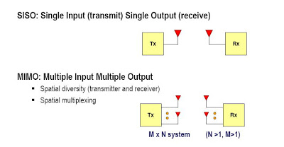

This refers to the number of transmit (M) and receive (N) antennas – for example, an AP with two transmit and three receive antennas is a "2 x 3" MIMO device.
The more antennas an 802.11n device uses simultaneously, the higher its maximum data rate.

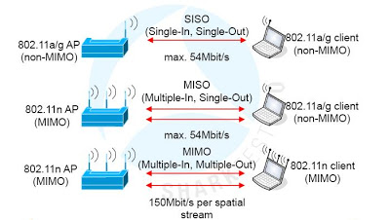

802.11n uses advanced signal processing techniques
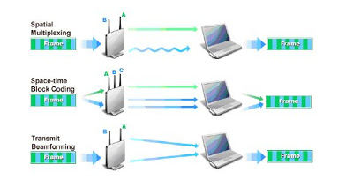

a. Spatial Multiplexing (SM)
- Spatial Multiplexing (SM) subdivides an outgoing signal stream into multiple pieces, transmitted through different antennas.
- Because each transmission propagates along a different path, those pieces – called spatial streams – arrive with different strengths and delays.
- Multiplexing two spatial streams onto a single channel effectively doubles capacity and thus maximizes data rate.
- All 802.11n APs must implement at least two spatial streams,up to a maximum of four.
- 802.11n stations can implement as few as one spatial stream.

b. Space-Time Block Coding (STBC)
- Space-Time Block Coding (STBC) sends an outgoing signal stream redundantly,using up to four differently-coded spatial streams, each transmitted through a different antenna.
- By comparing arriving spatial streams, the receiver has a better chance of accurately determining the original signal stream in the presence of RF interference and distortion.
- That is, STBC improves reliability by reducing the error rate experienced at a given Signal to Noise Ratio (SNR). This optional 802.11n feature may be combined with SM.

c. Transmit Beamforming (TxBF)
- Transmit Beam-forming (TxBF) steers an outgoing signal stream towards the intended receiver by concentrating transmitted RF energy in a given direction.
- This technique leverage additive and destructive environmental impacts
- This optional 802.11n feature is not yet widely implemented.

2. Frame aggregation A-MPDU & A-MSDU
- Frame Aggregation increases the payload that can be conveyed by each 802.11 frame, reducing MAC layer overhead from a whopping 83 % to as little as 58 % (using A-MSDU) and 14 % (when using A-MPDU).
- Legacy 802.11a/g devices can send no more than 2304 payload bytes per frame.
- But new 802.11n devices have the option of bundling frames together for transmission, increasing payload size to reduce the significance of the fixed overhead caused by inter-frame spacing and preamble.

There are two aggregation options:

MAC Service Data Unit Aggregation (A-MSDU):
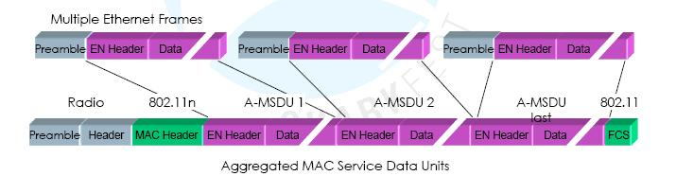

- Groups logical link control packets (MSDUs) with the same 802.11e Quality of Service,independent of source or destination.
- The resulting MAC frame contains one MAC header, followed by up to 7935 MSDU bytes.
- Whole frame must be retransmitted if no acknowledge .
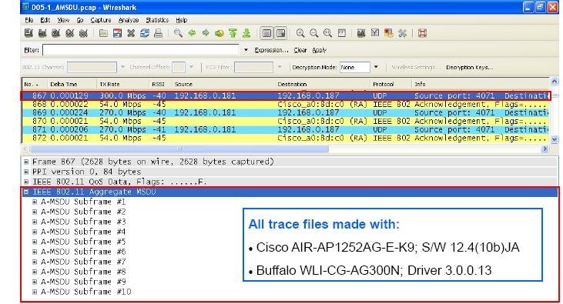

MAC Protocol Data Unit Aggregation (A-MPDU):
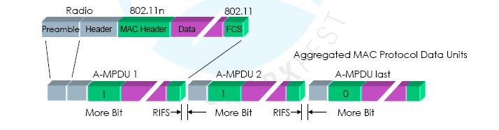

- Multiple Ethernet frames for a common destination are translated to 802.11 format and sent as burst.
- Complete MAC frames (MPDUs) are then grouped into PHY payloads up to 65535 bytes.
- Elements of an A-MPDUs burst can be acknowledged individually with one single Block-Acknowledge
- Only not-acknowledged A-MPDUs are retransmitted
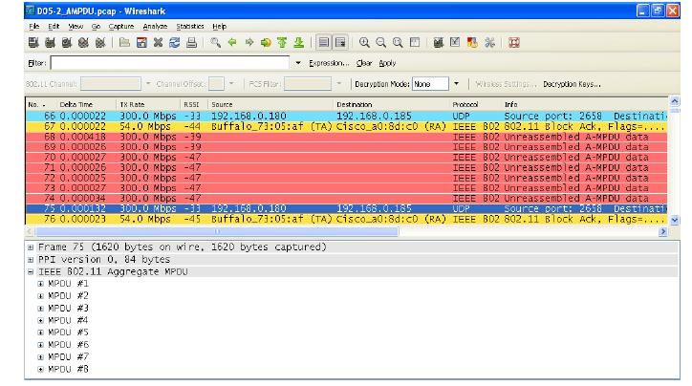

3. Channel bonding (40 Mhz channels)
- Legacy 802.11 products use channels that are approximately 20 MHz wide.
- New 802.11n products can use 20 or 40 MHz wide channels in either the ISM or UNII band.
- 802.11n WLANs will uses 40 MHz channels mainly in the 5 GHz UNII band.
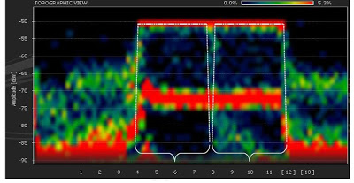

4. Block Acknowledgements (BLOCK ACK)
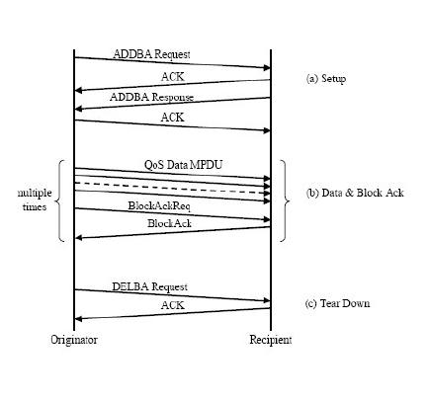
- Rather than sending an individual acknowledge following each data frame, 802.11n introduces the technique of confirming a burst of up to 64 frames with a single Block ACK(BA) frame
- The Block ACK even contains a bitmap to selectively acknowledgeindividual frames of a burst (comparable to selective acknowledges of TCP)
- The use of combined acknowledges can be requested by sending a Block ACK Request(BAR)
- The Block-ACK options are negotiated and confirmed with ‘Action’ framesdefined in 802.11e (WLAN QoS)
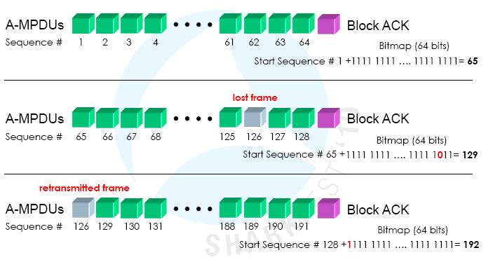

5. Modulation & Coding scheme (MCS)
- 802.11n APs and stations need to negotiate capabilities like the number of spatial streams and channel width.
- They also must agree upon the type of RF modulation,coding rate, and guard interval to be used.
- The combination of all these factors determines the actual PHY data rate, ranging from a minimum 6.5 Mbps to a maximum 600 Mbps

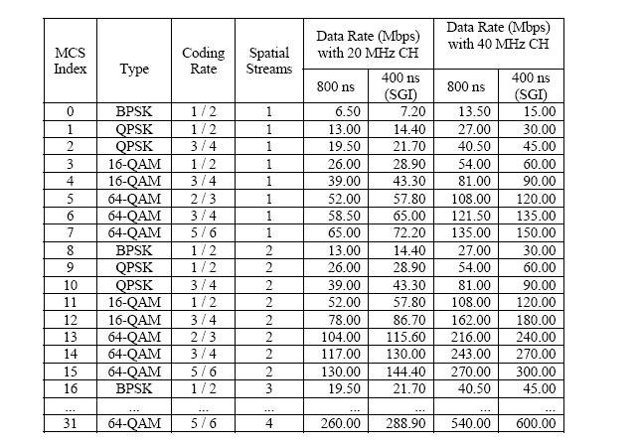

6. Short Guard Interval (short GI)
- Guard Interval is the time between transmitted symbols (the smallest unit of data sent at once).
- This Guard Interval is necessary to offset the effects of multipath that would otherwise cause Inter-Symbol Interference (ISI).
- Legacy 802.11a/g devices use an 800 ns guard interval, but 802.11n devices have the option of pausing just 400 ns.
- Shorter Guard Intervals would lead to more interference and reduced throughput, while a longer Guard Interval would lead to unwanted idle time in the wireless environment.
- A Short Guard Interval (SGI) boosts data rate by 11 percent while maintaining symbol separation sufficient for most environments.

7. 802.11n interoperability and coexistence

- Given the fact that millions of legacy 802.11a/b/g devices have been deployed to date, and that those devices operate in the same frequency bands used by 802.11n,enabling coexistence is critical.
- 802.11n deployments must therefore be able to "play nicely" with 802.11a/b/g, both by limiting 802.11n impact on nearby legacy WLANs and by enabling communication with legacy stations.
- These goals are accomplished using HT Protection and Coexistence mechanisms.

a. High Throughput (Greenfield) Mode:
- There are three 802.11n operating modes: HT, Non-HT, and HT Mixed.
- An 802.11n AP using High Throughput (HT) mode – also known as Greenfield mode – assumes that there are no nearby legacy stations using the same frequency band.
- If legacy stations do exist, they cannot communicate with the 802.11n AP. HT mode is optional.

b. Non-HT (Legacy) Mode :
- An 802.11n AP using Non-HT mode sends all frames in the old 802.11a/g format so that legacy stations can understand them.
- That AP must use 20 MHz channels and none of the new HT features .
- All products must support this mode to ensure backward compatibility, but an 802.11n AP using Non-HT delivers no better performance than 802.11a/g.

c. HT Mixed Mode :
- The mandatory HT Mixed mode will be the most common 802.11n AP operating mode for the next year or so.
- In this mode, HT enhancements can be used simultaneously with HT Protection mechanisms that permit communication with legacy stations.
- HT Mixed mode provides backwards compatibility, but 802.11n devices pay significant throughput penalties as compared to Greenfield mode.

8. RIFS
- RIFS is a means of reducing overhead and thereby increasing network efficiency.
- RIFS may be used in place of SIFS to separate multiple transmissions from a single transmitter, when no SIFS-separated response transmission is expected.
- RIFS shall not be used between frames with different RA values.
- The duration of RIFS is defined by the aRIFS PHY characteristic .
- A STA shall not allow the space between frames that are defined to be separated by a RIFS time, as measured on the medium, to vary from the nominal RIFS value (aRIFSTime) by more than ± 10% of aRIFSTime.
- Two frames separated by a RIFS shall both be HT PPDUs.

9. HT powermanagment
- 802.11n introduces two powersaving mechanisms that can be used by HT clause radios
- 802.11n radios still support legacy power save mode.
- The first new power save management is called Spatail Multiplexing PowerSave mode (SM power save)
- The purpose of SM powersave is powerdown the all but one of its radios
- For example a 4*4 MIMO device with four radio chains would power down three of its four radios
- The second Power save managment is Power save Multipoll (PSMP).
- PSMP is extention to the automatic power save mode
- U-PSMP is similar to U-APSD and uses trigger and deliver enabled mechanisms.
- Scheduled PSMP is similar to the S-APSD Power save

“What can we do to improve the performance and throughput of current 802.11 wireless networks?” We get
answers like the following: “If we transmit data over two channels instead of one, we can double our throughput.” “If we don’t have to acknowledge every data packet, we can make data transfer more efficient.”

Frequency Spectrum

HT (clause 20) technology defined by the 802.11n amendment is backward compatible with existing HR-DSSS (clause 18), ERP (clause 19), and OFDM (clause 17) technology. Because HR-DSSS and ERP radios operate in the 2.4 GHz ISM band and OFDM radios operate in the 5 GHz UNII band, HT technology is not frequency dependant and can be used in both the 2.4 GHz and 5 GHz bands.

MIMO

The heart and soul of the 802.11n amendment exists at the PHY layer with the use of a technology known as multiple-input multiple-output (MIMO). MIMO requires the use of multiple radios and antennas, called radio chains. MIMO systems use multiple antennas to provide for better antenna diversity, which can increase range. Transmitting multiple streams of data with spatial multiplexing provides for greater throughput and takes advantage of the old enemy known as multipath. Transmit beamforming is an optional smart antenna technology that can be used in MIMO systems to “steer” beams and provide for greater range and throughput.

HT Channels

1) HT radios use 20 MHz Orthogonal Frequency Division Multiplexing (OFDM) channels and may optionally use larger 40 MHz channels.
2) The OFDM channels used by 802.11n radios are larger in size and bandwidth than legacy 802.11a/g radios.
3) The greater frequency bandwidth provided by the OFDM channels used by HT clause 20 radios also provides for greater eventual throughput.

20 MHz Non-HT and HT Channels

1) 802.11a and 802.11g radios use 20 MHz OFDM channels. Each 20 MHz OFDM channel contains 62 subcarriers.
2) Each subcarrier is 312.5 KHz wide and can be separately modulated with part of the data stream. The first six and last five subcarriers are null because they act as a guard band for the channel. As well as the 11 guard band subcarriers, the center subcarrier is also null and is called the direct conversation (DC) subcarrier.
3) This leaves 52 subcarriers, as pictured in Figure 10.4. Forty-eight of these subcarriers transmit data,
while four of the subcarriers are used as pilot tones for dynamic calibration between the transmitter and receiver.
4) OFDM technology also employs the use of convolutional coding and forward error correction.

1) HT clause 20 radios also use the same OFDM technology and have the capability of using either 20 MHz channels or 40 MHz channels.
2) The 20 MHz channels used by HT radios use four extra subcarriers to carry data and subsequently have a smaller guard bands.
3) Therefore, HT channels can carry a little more data than a non-HT OFDM channel.
4) As a result, the HT 20 MHz channel can provide greater aggregate throughput for the same frequency space.
5) As pictured in Figure 10.5, an HT 20 MHz OFDM channel has 56 subcarriers.
6) Fifty-two of the subcarriers transmit data, while four of the subcarriers are used as pilot tones for dynamic calibration between the transmitter and receiver.

40 MHz Channels

HT Capabilities Element

1) HT STAs declare themselves as HT STAs by the transmission of the HT Capabilities Element in Beacon, Probe Request, Probe Response, Association Request, Association Response, Reassociation Request, and Reassociation Response frames.
2) Figure 10.18 shows the format of the HT Capabilities Element.
3) The HT Capabilities Element is 28 octets long and contains 8 fields used by the HT STA to advertise the optional HT capabilities it supports.

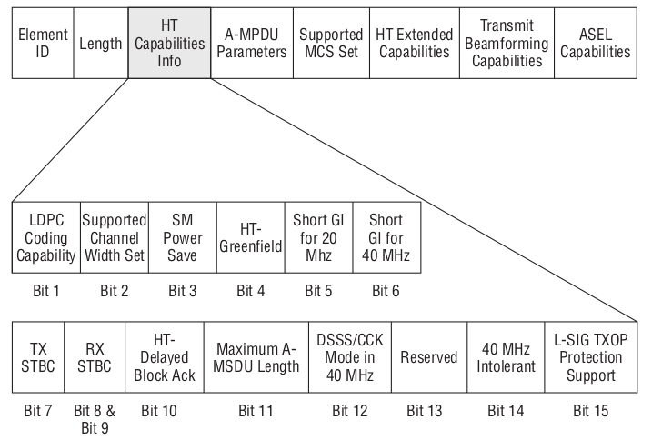
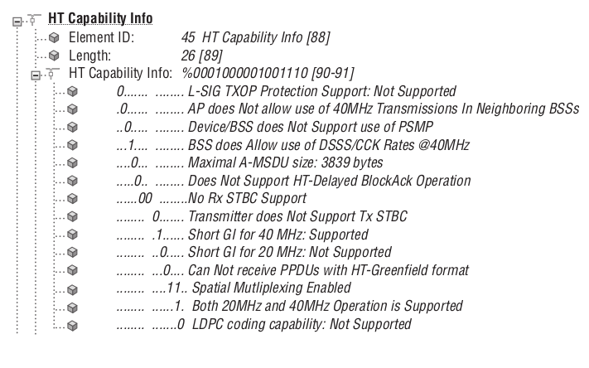

LDPC Coding Capability

1) Low-density parity check (LDPC) is a coding method for transmitting data in a noisy environment and provides excellent error correction and performance.
2) An STA indicates it is capable of receiving LDPC-coded packets by setting the LDPC coding bit to 1.

Supported Channel Width Set

The Supported Channel Width Set bit indicates the channel widths supported by a STA.
) If an HT station can support only 20 MHz channels, it advertises this by setting the
Support Channel Width Set bit to 0.
2) Configuring your 802.11n wireless network to only support 20 MHz channels might be something you do by design in the 2.4 GHz band.
3) This is because deploying 40 MHz HT channels at 2.4 GHz does not scale well in multiple channel architectures.
4) Although we have up to either 13 (Europe) or 11 (NorthAmerica) channels available in the 2.4 GHz ISM band, there are only three nonoverlap-ping 20 MHz channels available in North America. When the 20 MHz channels are bonded together to form 40 MHz channels in the 2.4 GHz ISM band, any two 40 MHz
channels will overlap, as pictured in Figure 10.21.
5) In other words, only one 40 MHz channel can be used at 2.4 GHz, and the possibility of a channel reuse pattern is essentially impossible.

1) Channel reuse patterns using 40 MHz channels at 5 GHz are feasible because there are many possible combinations within the UNII bands.
2) The use of 40 MHz HT channels in the 5 GHz UNII bands makes perfect sense because there are up to twenty-four (including channel 165,the 5.8GHz ISM channel available in the U.S.) 20 MHz channels that can be bonded together in various pairs, as pictured in Figure 10.22.
5) When a STA can support both 20 MHz and 40 MHz channels, it sets the Support Channel Width Set bit to 1.

http://www.hep.by/gnu/kernel/80211/smps.html

HT Field in n only mode
https://mrncciew.com/2014/10/19/cwap-802-11n-introduction/
HT Channels
1. 20MHz non-HT & HT Channels
– 802.11a/g, each 20MHz OFDM channel contain 64 subcarriers
– each subcarrier 312.5KHz wide.
In the 20 Mhz bandwidth they divided the 20 * 10 power 6 / 312.5 * l0 power 3 = 64 subcarriers
– First 6 & last 5 subcarriers are null because they act as guard band for the channel
– center subcarrier is also null & called the direct conversational(DC) subcarrier.
– This leaves 52 subcarriers (64-12).
– Out of 52, 48 transmit data while 4 are used as pilot tones for dynamic calibration between Tx & Rx.
– OFDM use convolution coding & forward error correction.
2. 40 MHz Channels
In n mode they combined the 1 and 6 to make the 40 Mhz channel
In the 40 Mhz bandwidth they divided the 40* 10 power 6 / 312.5 * l0 power 3 = 128 subcarriers
In the 128 subcarriers 14 are used for the guard band for the channel and the remaining are 114 subcarries outof that 6 subcarriers are used as pilot tones remaining are 108.
– 40MHz HT channel use 114 subcarriers
– 108 subcarriers transmit data & 6 subcarriers are used as pilot tones
– each 40MHz channels used by HT radios are essentially 2x 20MHz bonded together.
– One 20MHz channel termed as “Primary” & the other 20MHz termed as “Secondary”
– Primary & Secondary 20MHz should be adjacent 20MHz channels.
HT control field frame format
https://mrncciew.com/2014/10/20/cwap-ht-control-field/
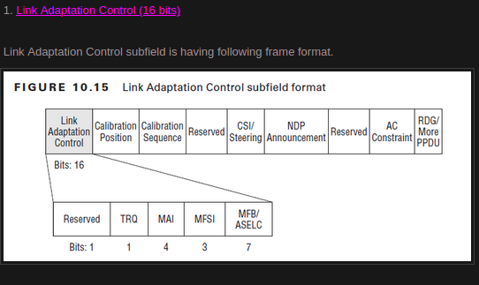

sudo apt-get install \
gtk2 \
libXtst \
gnome-desktop \
xorg-x11-xauth \
dejavu-lgc-sans-fonts

